3 Corners Double Show

MID STATES CLASSIC RABBIT SHOW

Russell County 4-H Building, Russell, KS

MAY 4, 2019

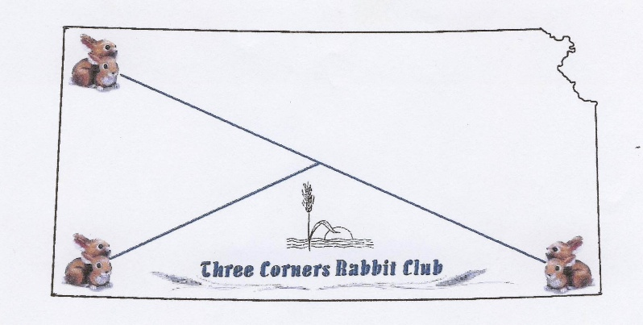

Building will be open at 6:30 a.m.

All rabbits must be entered by 8:00 am.

Judging will begin at 8:30 a.m.

JUDGES
TARA PARKER (OK), DAN DANIELS (KS)
DAVID KROENKE (KS)

BLAINE MAIER (KS) as backup if needed

Superintendent: RICHARD QUINN 785-639-6500
Secretary: LISA QUINN 785-656-3448

DAY OF SHOW ENTRIES:
$3.00 Open and Youth, $1.50 Fur/ Wool

MOTHER’S DAY SPECIAL – BEST DOE CONTEST
$5.00 per Entry - Cash payback
1st Place 35% of entry money
2nd Place 25% of entry money
3rd Place 15% of entry money

YOUTH JUDGING AND BREED ID CONTESTS TOWARD THE NATIONAL JUDGING CONTEST TEAMS WILL BE HELD STARTING AT 8:30

STARTING BREEDS: MINI LOPS, HAVANA, CALIFORNIANS

OPEN BREEDS WILL BE SHOWN UNTIL THE CONCLUSION OF THE YOUTH CONTESTS

BOTH OPEN & YOUTH
Mini Rex, Mini Satin and Satins, Mini Lops

OPEN ONLY
Californians, Flemish Giants, Florida White, Havana, New Zealand, Standard Chinchilla, Holland Lops

Please contact Show Secretary Lisa Quinn 785-656-3448 or Richard Quinn 785-639-6500 or Blaine Maier 785-483-1717 if you want a breed sanctioned that is not listed above.

Snacks and drinks will be available

RAFFLE – Your contributions will be appreciated. All animals donated must be healthy and pedigree supplied. An ARBA Judge or Registrar will check the rabbits. If any disqualifications are found they will be prominently displayed. Prices and drawing time will be announced.

REGISTRAR: Will be available

SANCTIONS

American Rabbit Breeders Association Sanctioned Show
Eric Stewart, Executive Director: Box 5667, Bloomington, IL 61702 Membership dues $20.00 per year, $50.00 for 3 years, Husband & Wife membership $30.00 per year, $75.00 for 3 years, Youth membership $12.00 per year, $30.00 for 3 years.
Plan to attend the ARBA National Convention in RENO, NV Oct 19 - 23, 2019

Kansas State Approved Sweepstakes Show
Jillian Oberly 1855 Florida Rd. Pomona, KS 66076 Display Points at this show shall count toward the annual Kansas State Display Trophies. To be eligible to receive these awards, an exhibitor must be a member of the state association or join before the judging begins.

DIRECTIONS TO SHOWROOM

From the South or North via HWY 281: Travel through the historic brick streets of Russell to 8th (State) Street. Go east on State Street for .8 miles until reaching Fairway Drive. The 4H building is on the west side of the street.

From I-70 East or West: Take exit 184 and travel north on Fossil Street (also HWY 281)
for 2 miles. Turn east on 8th (State) Street for .8 miles, turn south on Fairway Drive. The 4H building is on the west side of the street.

Show Rules:

1). This is an ARBA and KSRBA sanctioned show and will be governed by the latest ARBA show rules. Filing of an entry indicates acceptance of these rules.

2). DAY OF SHOW ENTRY
$3.00 Open and Youth, $1.50 Fur and Wool.
Make checks payable to: 3 Corners Rabbit Club.

3). Please remember the same rabbit cannot be entered in both the Youth and Open Shows. Youth and Open entries must use separate entry forms. All rabbits must be entered in the name of the bona fide owner. All fur entries must be entered in the regular class.

4). All rabbits must be permanently and legibly tattooed or they may be disqualified from competition.

5). Owners are responsible for getting their own rabbits to the show table. All rabbits entered in the youth show must be handled by youth. Youth entries exhibited by adults will be transferred to the open show.

6). Neither 3 Corners RBA, nor the Russell County Fair Grounds will be responsible for any injury or accident occurring during the show. Please understand the below Kansas law before entering, it is also posted in the show room.

KS LAW K.S.A. 60-4001 THROUGH 60-4004
UNDER KANSAS LAW, THERE IS NO LIABILITY FOR AN INJURY TO OR DEATH OF A PARTICIPANT IN DOMESTIC ANIMAL ACTIVITIES RESULTING FROM THE INHERENT RISKS OF DOMESTIC ANIMAL ACTIVITIES, PURSUANT TO SECTIONS 1 THROUGH 4. YOU ARE ASSUMING THE RISK OF PARTICIPATING IN THIS DOMESTIC ANIMAL ACTIVITY.

7) Parents are responsible for damage done by their children, please keep track of them. Attendants should not enter any other building on the Russell County Fair Grounds. We will do all within our power to have a safe show, please do the same.

8). 3 Corners RBA reserves the right to substitute or add a judge if necessary.

9). All exhibitors must fill out ARBA two part cards and turn in with their entry. It is exhibitors’ responsibility to pick up their comment cards after judging. They will not be mailed. Your comment cards and entry forms must match. All changes must be made on the entry form NOT AT THE SHOW TABLE. If the comment cards don’t match the entry form, rabbits may be placed incorrectly or given a “no place”. Please inform Show Secretary of any changes made to an entry.

10). Any animal showing signs of illness or disease will be removed from the showroom.

11). Grooming tables and chairs should not block isles.

12). Interpretation of the show rules will be by the show officials.

13.) The 3 Corners Rabbit Club will sanction all breeds showing 10 or more rabbits for our 2019 show.

No Dogs (except those allowed by law), Cats, Scooters, Roller Skates, or Roller Blades allowed in the building.

RUSSELL LODGING:

Fossil Creek Days Inn
1430 S Fossil 1225 S Fossil
785-483-4200 785-483-6660

Glenwood RUSSELL’S INN
1405 S Fossil
901 S Fossil
785-483-2488 785-483-2107

National Mini Rex Rabbit Club:
Jennifer Whaley, P.O. Box 712499, Santee, CA 92072 619-933-6505 Email: minirexsecretary@yahoo.com
Membership: (1 Yr) Adult $15.00 - Youth $15.00 - H/W $20.00 - Family $30.00 - Foreign: $ 30.00 - (3 Yr) Adult $40.00 - Youth
$40.00 - H/W $50.00 - Family $75.00 - Foreign: $ 80.00. Sanction Fee: Open $10.00 - Youth $10.00,

American Satin Rabbit Breeders Association
Rita Peralta, 2233 Snyder Ln, Stockton, CA 95215 Phone: 209-931-0983 Email: peraltarita@comcast.net
Membership: (1 yr) Adult: new $15.00, renewal $10.00 - H/W: new $17.00, renewal $12.00 - Youth: new $13.00, renewal $8.00 -
Family: new $19.00, renewal $14.00 - (3 yr) Adult: new $30.00, renewal $25.00 - H/W: new $35.00, renewal $30.00 - Youth: new
$25.00, renewal $20.00 - Family: new $40.00, renewal $35.00 - Foreign add $10.00 per year surcharge - Sanction Fee: Open
$12.00 - Youth $7.00 (Fees cover both Satins and Mini Satins)

American Standard Chinchilla Rabbit Breeders Association:
Patricia Gest - 1607 9th Street West - Palmetto, FL 34221 941-729-1184 cgest@aol.com
Membership: (1 yr) Adult $8.00 - H/W $12.00 - Youth $5.00 - (3 yr) Adult $22.00 - H/W $27.00 - Youth $12.00 - Foreign service
charge $3.00. Sanction Fee: Open $7.50, Youth $7.50 (Youth free if requested with Open and held same day)

Californian Rabbit Specialty Club
Donald R Mersiovsky,1156 Elm Grove Spur, Belton, TX 76513, (254)939-0345 Email: secretary@nationalcalclub.com
Membership: Adult-$10 (1yr), $28 (3 yr); Youth $5: H/W-$15 (1 yr), $43 (3 yr). Sanction Fees: OPEN $10.00 - YOUTH $5.00.
Send sanction requests to Don Mersiovsky. Send completed sweepstakes reports to Ken McCracken, 13550 Spring-Cypress Rd,
Cypress, TX 77429. Phone: 832-260-2398 Email: caltxrab@msn.com

ENTRY FORM

Exhibitor Name _______________________________________ OPEN: ___ YOUTH: ___

Address: ______________________________________ Phone: [_____]________________

City: ________________ State: _______ Zip: __________ E-mail: __________________
Entries: $3.00 Open and Youth, $1.50 Fur/Wool.

# | BREED/VARIETY | TATTOO | CLASS/SEX | FEE
1.
2.
3.
4.
5.
6.
7.
8.
9.
10
11
12
13
14
15
16
17
18
19
20
21
22
23
24
25
26
27
28
29
30

TOTAL RABBITS: __________________ PAYMENT: _________________

