Kansas State Rabbit Breeders Association

77th Annual Convention

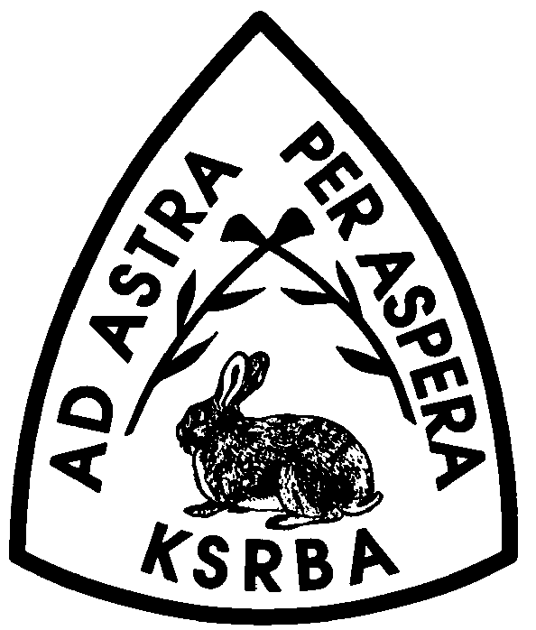

November 4-5, 2023

Annual Show for Rabbits & Cavies
Kansas State Fair Grounds – 2000 North Poplar, Hutchinson
Building will be open 12 Noon on Friday and close at 10 PM.
Open Saturday morning at 6 AM, closed at 5 PM.
All rabbits must be entered by 7:30 AM, Saturday.
Open Show begins at 8 AM, Youth at 1 PM.
Barn open Sunday at 7 AM

Judges: Dave Cardinal, Vic Vogts, Eric Stewart

Show Officials:
SUPERINTENDENT Gary Michaud Assistant: Karen/Vic Vogts

SECRETARY Nancy Kennedy
2484 151st Road, Atlanta, KS 67008
nancyk@kennedyrabbitry.com
Cell phone: 316.655.7320

REGISTAR Karlee Wigton, Katherine Wist

RAFFLE Kathy Rariden
Each all breed club is to provide 6 items for the raffle. All donations are welcome.
Drawing will be held Sunday

DECORATING Melissa Tillery,chr, Melissa Wist, Belinda Howard

Specialty Shows
Satin/Mini Satin (Friday Night & Saturday), Havana (Sunday),
Florida White (Sunday), French & English Lops (Sunday), Mini Rex (Friday), Jersey Wooly (Sunday), California (Sunday), New Zealand (Sunday)
Entries:
Online Entries only www.easy2show.com- deadline October 31, 2023 cost $4.50 Open & Youth, $4.00 Fur & Wool.
If unable to enter online please mail to Nancy Kennedy postmarked by October 26, 2023

Awards:
Open and Youth
BEST IN SHOW – Trophy RESERVE IN SHOW – Trophy 1st RUNNER UP – Trophy

BEST OF BREED – Rosette BEST OPPOSITE SEX – Rosette

BOB and BOS awards only if 10 or more are shown in Open or Youth

Breeds Sanctioned:

Open –Californian, Crème D’Argent, Dutch, English Lop, , French Lop, Havana, Himalayan, Holland Lop, Jersey Wooly, Lionhead, Mini Lop, Mini Rex, Mini Satin, Netherland Dwarf, New Zealand, Palomino, Polish, Satin, Standard Chinchilla

Youth –Californian, Dwarf Hotot, English Lop, French Lop, Havana, Holland Lop, Jersey Wooly, Mini Lop, Mini Rex, Netherland Dwarf, Standard Chinchilla

KSRBA will sanction any breed of rabbit recognized by ARBA for 2024 if 10 or more show in the 2023 show. If 10 or more are not shown in any breed the sanction will be dropped from the next year’s show. Anyone wishing to sanction a non-sanctioned breed please contact Nancy.

Banquet
Attend the Annual State Convention Banquet on Saturday Night November 4,2023.
Banquet will be held at 6:30 PM. Cosmosphere 1100 N Plum, Hutchinson, KS 67501

Menu- Hog Wild Buffet

Tickets - $ 18.00 adult/ $15.00 9 & under- per person- You must order your tickets with your entries.

GET YOUR RESERVATIONS IN EARLY- THERE WILL NOT BE TICKETS FOR SALE AT THE SHOW!

PROGRAM – Youth Royalty Winners, Sweepstakes Winners, and other awards.

Show Rules:

- This is an ARBA and KSRBA sanctioned show and will be governed by the latest ARBA show rules. Filing of an entry indicates acceptance of these rules. This is a two day show and judging order will be set by superintendent. KSRBA reserves the right to add or change judges as they see fit.

- Entries accepted online only at www.easy2show.com $4.50 Open and Youth, $4.00 Fur and Wool. Online entries by October 31, 2023.Online ear number changes until Nov 2. Only those unable to enter online may enter postmarked by October 26, 2023. Make checks payable to KSRBA or pay online with paypal to ksrbashowsec@gmail.com Payment will be accepted day of entry.. A $30.00 surcharge will be assessed for a check returned unpaid. Until the check is paid, exhibitor will not be allowed to enter any further KSRBA shows.

- Animals may enter the barn between 12 Noon and 10 PM on Friday and then starting at 6 AM on Saturday. Cooping will be on a first come, first served basis and there are no guarantees of pens being available. All exhibitors (open and youth) must check in with the show secretary by 7:30 am November 4, 2023. Otherwise comment cards will be pulled in belief exhibitor is not present.

- On Saturday all feeding should be completed by 4:30 pm. The barn will close at 5 PM and will not be reopened Saturday evening. BIS will not be selected until Sunday. Starting time for judging on Sunday will be announced at Banquet.

- Please remember the same rabbit cannot be entered in both the Youth and Open Shows. Youth and Open entries must use separate entry forms. All rabbits/cavies must be entered in the name of the bona fide owner. All fur entries must be entered in the regular class. All entries which include email address will receive email confirmation. Youth age is 5 – 18 and they must carry their own rabbits/cavies to the table.

- All rabbits must be permanently and legibly ear marked or they will be disqualified from competition.

- Owners are responsible for getting their own rabbits to the show table. Carriers are not provided.

- Neither Kansas State RBA nor the Kansas State Fair Grounds will be responsible for any injury or accident occurring during the show. Please understand the below Kansas law before entering, it is also posted in the show room.

KS LAW K.S.A. 60-4001 THROUGH 60-4004
UNDER KANSAS LAW, THERE IS NO LIABILITY FOR AN INJURY TO OR DEATH OF A PARTICIPANT IN DOMESTIC ANIMAL ACTIVITIES RESULTING FROM THE INHERENT RISKS OF DOMESTIC ANIMAL ACTIVITIES, PURSUANT TO SECTIONS 1 THROUGH 4, YOU ARE ASSUMING THE RISK OF PARTICIPATING IN THIS DOMESTIC ANIMAL ACTIVITY.

Parents are responsible for damage done by their children, please keep track of them. All activities will be held in the rabbit and poultry building. Convention attendants should not enter any other building on the grounds. We will do all within our power to have a safe show, please do the same.

- Kansas State RBA reserves the right to substitute or add a judge if necessary.

- Exhibitors must fill out comment cards for late entries and turn in with their entry. The show secretary will fill out comment cards for pre-entries.

- Equipment and Sales Displays must have permission from the show superintendent to set up. There will be a charge of $60.00, plus $10.00 per table rented. Please let Nancy Kennedy know how many tables are needed by Oct 31.

- Any animal showing signs of illness or disease will be removed from the showroom. “KSRBA reserves the right to refuse entries from exhibitors placing an entry from all locations within 50 miles which has had a confirmed outbreak of RCV/RHD/VHD within the past 60 days of the entry deadline

- Due to limited space all rabbits in the show room must be entered. Sale Coops are available for $3.00 each-only one rabbit per cage and must meet ARBA minimum weight. Do not have to reserve coop but may. No refunds on prepays.

- Grooming tables and chairs should not block isles.

- KSRBA does not allow animals under ARBA minimum breed weight in the show barn.

- Interpretation of the show rules will be by the show officials

- Weather permitting grooming of wool breeds needs to be done outside of the barn.

Youth Contests:

COMMITTEE Chair: Alan Kennedy akennedy@kennedy.com

In order for all Youth to be able to participate in the youth contests, no youth rabbits will be judged before 1 PM on Saturday, Nov 4. However, all rabbits must be in the barn and all entries made by the times listed in the show rules.

Judging, Identification and Showmanship contests are open to all youth entered in the show. Royalty is open only to youth KSRBA members.

All youth events will run concurrently from 8 AM to 12 Noon on Nov 4, 2023. Tie breakers and call backs will be from 12 Noon to 1 PM if necessary. The Royalty test will begin promptly at 8 AM Saturday. Participants must be ready to begin at this time.

Awards for the contests and royalty will be presented at the KSRBA Banquet. Please pick up all awards and results before check out on Sunday, as they will not be mailed.

VOLUNTEERS FOR THE KSRBA YOUTH ROYALTY CONTESTS ARE NEEDED.
PLEASE CONTACT: Alan Kennedy akennedy@kennedy.com or sign up during the State Fair weekends.

Adult Contests:

This Adult Class is to encourage all our members to continue striving for the knowledge our youth must maintain and to allow past youth members to keep their knowledge current.

Awards will be presented to the highest scores on the written test and in the Identification contest by KSRBA members age 20 or older.

Tests will be taken in the show room and must be turned in by 11 AM. Identification should be done after the youth have finished between 11 and 12 noon.

Come join the fun :-)

Youth Judging Team Silent Auction

Once again a Silent Auction will be held in conjunction with the Kansas State RBA Convention. This is the main moneymaking event for the KS Team members that will be representing Kansas at the ARBA Convention. A portion of this money will be used to defray some of the expenses incurred such as the Youth Banquet ticket. All KSRBA members are welcome to provide items for this activity. Quality animals may be donated as long as a pedigree is included and there are no disqualifications on the animals. All animals must be preapproved by contacting Amy Bryan by October 31, 2023. Please contact Amy Bryan for additional information. The Silent Auction will end on Sunday at 11:00 a.m.

YOUTH EDUCATIONAL CONTESTS
Chairperson: Amy Bryan
PURPOSE: To acknowledge excellence among Kansas youth members who create exhibits that show some aspect of the rabbit or cavy industry.
RULES:
- Any Kansas youth member is eligible to compete. Attendance at the KSRBA Convention is not necessary.
- Exhibits must be informational or promotional of either rabbits or cavies, or include a rabbit or cavy as part of their design.
- A contestant may enter as many subdivisions as they choose, but may submit only one entry per each subdivision.
- Each entry must be the work of the contestant and must have been completed in the 12 months prior to the KSRBA Convention.
- Clearly indicate on the back of each entry: your name, address, age, KSRBA club you are a member of, and the class you are entering within the divisions. Classes: Pre-Junior (ages up to 9), Junior (ages 9-11), Intermediate (ages 12-14), Senior (ages 15-18) and Adult (19- over).
- Bring all exhibits to the youth contest area at the KSRBA Convention by 9 am Saturday.
- All entries will receive ribbons. Top entries in each class will be reevaluated to determine the State winners. State winners will be announced at the KSRBA Banquet.
- Exhibitors should claim all exhibits by 9:00 am Sunday morning. If you are unable to attend please make arrangements for someone to pick up your educational entry.
DIVISIONS
Art Division (Framing, with or without glass, and /or an easel to display is optional)
- Drawing b. Painting c. Sculpture d. Carving
Crafts Division (Display to best suit the item so as to be clearly and easily visible. Small items may be fastened to a display board or in a display box for protection.)
- Ceramics or Pottery b. Handmade Jewelry c. Needlework
d. Clothing (made by exhibitor) e. Puppet or Stuffed Animal f. Stenciled Item
g. Wearable Art f. Any Other Craft
Creative Writing Division (Exhibit in a protective report cover or clear plastic sleeve for protection.)
- Poem b. Short Story
Educational Division
- Display b. Poster c. Game
Photography Division (All photographs must be matted or framed. Photos no smaller than 4" x 6" or larger than 11" x 14".)
- Single Photo – Black & White b. Single Photo – Color
c. Photo Series Three to six pictures mounted together to tell a story or convey an idea.
Woodworking and Metalworking Division
- Decorative Rabbit or Cavy Equipment

Specialty Shows:

SATIN/MINI SATIN- Friday Night - See Karen Vogts for entries

SATIN/MINI SATIN-Saturday - See Clarence Linsey for entries

HAVANA- Sunday _ See Kim Powell for entries.

FLORIDA WHITE- Sunday - See Gary Michaud for entries

ENGLISH/FRENCH LOP- Sunday See Dwight Kamm for entries.

JERSEY WOOLY-Sunday See Melissa Tillery for entries.

MINI REX- Friday See Dianne Jenkins for entries.

Californian- Sunday See Kenny Wilson for entries.

New Zealand- Sunday See Kenny Wilson for entries

