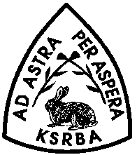
Kansas State Rabbit Breeders Association
PHOTO RELEASE FORM

I, Click or tap here to enter text., hereby grant permission to the Kansas State Rabbit Breeders Association to use photographs and/or video of me and/or my child(ren) in publications, news releases, online and in other communications related to the mission of the Kansas State Rabbit Breeders Association.

Signature: Click or tap here to enter text. Date: Click or tap here to enter text.

Name:Click or tap here to enter text.
Address: Click or tap here to enter text.
Phone: Click or tap here to enter text. Email: Click or tap here to enter text.
Please send completed documents to Ashley Barnes at bcbunniesks@gmail.com.
Thank you,
The Kansas State Rabbit Breeders Association

